Engineer-it

Modelling process

Iain A MacLeod July 12 2021

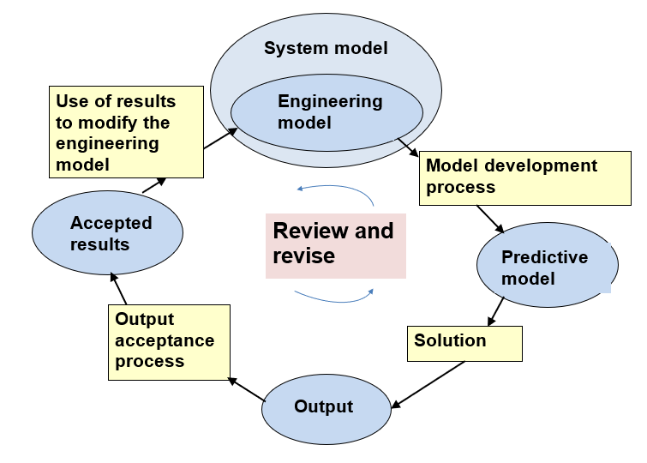
Figure 1 The modelling process

Figure 1 is a diagram of the modelling process

The rectangular boxes represent processes and the elliptical boxes represent outcomes from processes.
The outcomes are:
- The system model is the design information for the complete real world system. This is traditionally in the form of drawings and specifications but also includes BIM models.
- The engineering model is a subset of the system model that defines the features of the structure needed for the technical assessment.
- The analysis model is a mathematical model of the structure represented by diagrams, model specifications and data for the software.
- The solution is the raw output from the computer.
- The accepted output is the part of the output that has been assessed and approved for use in the technical assessment process.

Modelling activities

Figure 2 shows a range of modelling activities.

Requirements assessment
While the requirements for a structural analysis are normally evident, it is important to reflect on them and to draw up a requirements statement for complex or non-standard contexts.
Questions for requirements assessment include:
- Stresses and internal forces: Have the locations and target accuracy been identified? Has the distinction between local and resultant stresses been clearly identified?
- Displacements: Where do the displacements need to be defined and to what accuracy?
- Natural frequencies and mode shapes: What range of natural frequencies need to be considered?
- Fundamental requirements assessment question: Have all required performance issues been identified and included in the requirements statement?

Model validation
Model validation is the process of ascertaining whether the model is capable of meeting the requirements.
A model validation is carried out by listing all the assumptions made for the model. To do this, one needs validation information i.e. information which discusses the applicability of assumptions. Such information is not readily available in conventional texts on structural analysis - but see Reference 1.
It is good practice to prepare a validation analysis for non-standard contexts. Ways of presenting these are given in references 1 and 4.
While having an initial validation exercise is very important, validation information can emerge from the results especially from sensitivity analysis. A constant lookout for information that will assist the validation should be held.
Questions for validation include:
- Assumptions: Have all the assumptions for the model been identified?
- Validation information: Is all relevant validation information available?
- Test results: Are there test results available to support the validation?
- Fundamental validation question: Is the model capable of satisfying the requirements?

Results verification
Results verification is the process of seeking to ensure that the model has been correctly implemented.
Both formal and informal strategies should be used to seek to identify faults in the implementation of the model. A formal checklist can be used but also regular quantitative and qualitative checks should be carried out.
Verification checks include:
- Data checking: Has there been sufficient resource applied to data checking?
- Overall equilibrium Has a check been made on overall equilibrium? For example the sum of the total vertical reactions should be checked against the total vertical load that was expected to be applied to the model.
- Symmetry: If there is symmetry has it been checked via a symmetric loadcase?
- Form of results: Does a qualitative assessment of the results show any anomalies?
- Values of results: Are the values of the results in the expected range?
- Checking models: See following paragraph.
- The fundamental verification question: Has adequate resource been allocated to minimise the risk of implementation errors in the model?
Checking model
Checking the model against another frame of reference - a checking model - can be a valuable review activity. The checking model may take the form of:
- A ‘back of an envelope’ calculation i.e. a hand calculation based on a simplified model of the system to provide a quick check
- A simplified model of the system which requires software for the solution.
- A repeat of the model using different software and/or different personnel

Simplified models should be assessed for validity. It is important that they are able to adequately represent the main features of behaviour being investigated. Also, care should be taken in relation to correlation between two models. False correlations are not uncommon.

Results interpretation
Results should be regularly interpreted to seek to develop understanding of the behaviour of the system. This can contribute to the validation and verification processes.
Sensitivity Analysis
Varying the model to assess the effect of the variations on behaviour is a very important review activity. Doing this helps to develop understanding of behaviour which can inform both the validation and verification processes.
Competence assessment
It is important to ensure that those using the software have the necessary competence.
Software assessment
Software validation The software should be validated by asking the question: Is the software capable of implementing the model?
Software verification The software should be verified by asking questions such as: Is there adequate evidence that the software has been checked for accuracy? Have benchmark analyses been carried out?

Modelling Review Process
Figures 2 shows a basic review process and Figure 4 represents a full review process. The former would be used in a standard context that is familiar to those working on the type of model. The latter would be used in an innovative situation where there might be significant uncertainty, complexity and/or where the context is safety critical - e.g. nuclear power installations. Results verification is always needed but in standard contexts validation may not need deep consideration and sensitivity analysis may not be required. In a complex innovative situation very careful attention to all the review activities may be essential.

The initial Review
Activities for an initial review may include:
- Make predictions about the expected outcomes at the outset and check these against the results as they emerge from the process
- Define the requirements for the model
- Assess competence and software
- Carry out an initial validation of the model.
- Set up the data with a simple loadcase (a checking loadcase) and carry out a results verification.

Ongoing review
- Continue with development/production runs. Do quick qualitative verification on a regular basis and further quantitative checks as appropriate. Continue to consider model validation issues if the model is altered and to interpret validation information from the results if practical.
- As appropriate, carry out sensitivity analyses to develop understanding of the behaviour of the system being modelled and to contribute to the validation analysis.
- Continually challenge the adequacy of the inputs to and the outputs from the process.

Final review
Carry out final versions of the model validation and results verification and record the results as appropriate to the required QA procedures. Assess the outcomes against the initial predictions and seek to identify the sources of important differences between the two.

Bibliography

Macleod I A (2005) Modern Structural Analysis Thomas Telford Ltd.
Macleod I A and Weir A (2016) Principles for Computer Analysis of Structures, Essential Knowledge Text No 14. Institution of Structural Engineers

Appendix Example of a modelling review for a roof truss

This example provides an example of a modelling review report.

The Engineering model
Figure 9 gives an elevation and connection details for a roof truss. It is supported at each end on masonry walls. The trusses are at 2.5 m centres.

The Requirements
The purpose of the model is to estimate the deflection and internal forces in the structure under permanent and non- permanent loading.

Loading
Loading on roof: Permanent Load G = 1.3 kN/m²
Non-permanent load Q = 1.0 kn/m²
Design load for quoted case w = 1.35G + 1.5Q

The Analysis Model
Figure 10 shows a plane frame model of the truss:
Element types:
Chords and posts: Beam elements - bending and axial deformation - with no shear deformation
Diagonals: Truss elements - only axial deformation, no bending.

Section and material properties are given in Table 1.

Table 1 Section and material properties and element types
Section | Area m² | I  m⁴ | E (kN/m²) | Elements | Element type
Chords -double 100x50 timber | 0.01 | 8.33E-6 | 12.0E6 | 1 to 22 | Beam
Diagonals - 6 mm diameter stainless steel cable | 2.83E-5 | - | 197E6 | 23 to 36 | Truss

Material: Linear elastic for all elements
Restraints:
Node 1 - pin
Node 2 - horizontal roller

Loading The loading applied at point nodes vertically downwards is given in Table 2.

Table 2 Loading applied in model
Nodes | Applied vertical nodal loads
10 to 15 | 12.2 kN
9,16 | 6.1 kN

Software used: Strand7

Results

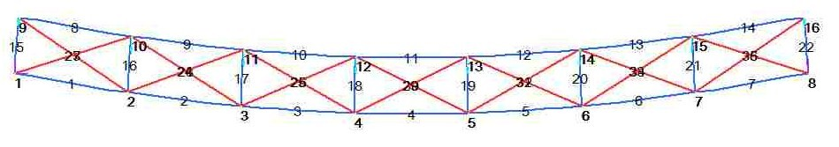
Figure 11 Deflected shape

Graphical output - Figure 11 deflected shape, Figure 12 bending moments in the chord elements, Figure 13 axial forces in the chord elements
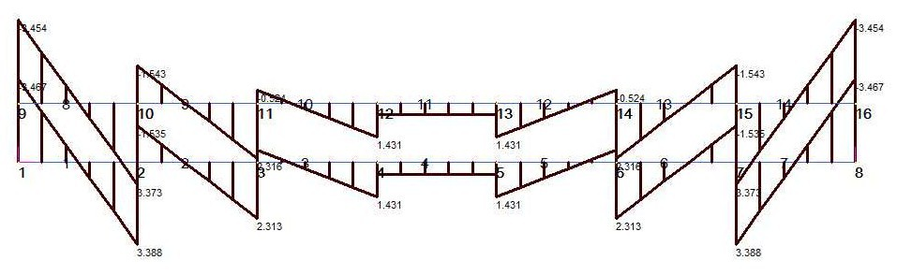

Figure 12 Bending moments in chord elements
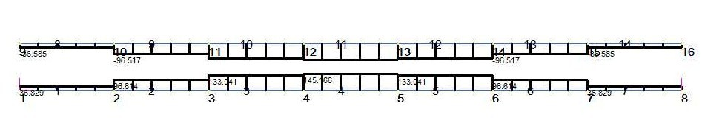
Figure 13 Axial forces in chord elements

Model Validation

Elasticity Timber: Acceptance criterion: design to code of practice.
Steel wire: Design to code of practice.

Element types
Beam elements for timber members: Timber members and connections to be designed to take combined axial forces and moments predicted by the model.
Bending theory: Criterion for neglecting shear deformation: span:depth > 5 Minimum span:depth = 0.75/0.1 = 7.5 OK
Truss elements for the diagonals. These elements will not take compression and therefore the compression diagonals should be removed for each loadcase or use software feature to neglect the effect of compression diagonals. ERROR

Connection eccentricity
Member axes do not meet at a single intersection point as shown on Detail A This cannot cause moments in the diagonals (they cannot take moment) and is unlikely to cause significant extra moments in the timber elements. OK

Restraints
The roller support at node 8 allows horizontal movement at that end. There will be some horizontal restraint at the level of the support but it is conservative to neglect it OK

Euler buckling
Diagonals will not take compression (see above). Top chords and posts to be designed to code of practice.

Loading
Check values of point loads used:
Loading on roof: Permanent Load G = 1.3 kN/m²
Non-permanent load Q = 1.0 kn/m²

Design load w = 1.35G + 1.5Q = 1.35x1.3 + 1.5x1.0 = 3.26 kN/m²
Load/m on trusses = wxS = 3.26x2.5 = 8.15 kN/m
where S is the spacing of the trusses
Load at internal panel point on truss = 8.15x1.5 = 12.2 kN
Load at external panel point on truss = 12.2/2 = 6.1 kN
OK

Results verification
Data check: Nodal coordinates - checked. Element properties - checked. Loading - checked.

Equilibrium of vertical load:
Applied vertically 6x12.2 + 2x6.1 = 85.4
Sum of vertical reactions at nodes 1 and 8 - 2x42.6999 = 85.3999 OK
(Note: value of 2.6999 from computer output. Use of a high number of significant digits for this check is recommended -see Reference 1, Section 3.6.2)
Restraints:
Zero deformation in X and Y directions at node 1
Zero deformation at in Y direction at node 8 OK

Symmetry: Vertical nodal reactions = 42.6999 are the same at nodes 1 and 8 (Note: value is from computer output. Reason for use of high number of significant digits as for vertical equilibrium check) OK

Check moment equilibrium at Node 2
Figure 14 shows the moments extracted from the results.

Sum of moments at Node 2 (clockwise +ve)
4.923 - 3.388 - 1.535 = 0.0 OK

:

Form of results - displacements
The deflected shape (Figure 11) is curved as would be expected with UD loading. The distorted shapes of the panels show significant shear deformation of the type shown in Figure 15

Form of results - internal forces
- The chord bending moments decrease towards the centre line and there are points of contraflexure in them except for the centre element where the BM is constant. Having points of contraflexure near to the centre of the beams (as in this case) is typical of vierendeel action. A (secondary) vierendeel action component is expected to occur with this type of frame because of the moment continuity between the chords and the posts. The reason why the chord moments decrease towards the centre line is because they are mainly a function of the global shear force on the truss - a characteristic of vierendeel action.
- The axial forces in the chord members increase from the supports to the centre of the truss. This is because they act like the flanges of an I beam, the axial loads in which are dependent on the bending moment in the beam which increases towards the centre line. The equivalent bending moment in the truss is the ‘global’ moment - see next section.
- The axial loads in the tie members are approximately equal and are opposite in each panel and decrease towards the centre line of the truss. This is consistent with them resisting the shear forces across the truss panels (the ‘global’ shear forces).

Checking model - internal force actions
1. Check forces in diagonals in panel next to support.
Figure 16 shows the forces in the left end panel.

Shear in panel = 42.7 - 6.1 = 36.6 kN
Assume that this is taken by the diagonals equally.
Therefore estimated force in a diagonal N_{de} = (36.6/2)/sinθ
θ = atan(0.75/1.5) = 0.464 rad sinθ = sin(0.464) = 0.448
N_{de} = (36.6/2)/0.448 = 40.85 kN
From the results (quoted in Figure 16) the average of axial forces in diagonals
N_{d} = (30.858+30.585)/2 = 30.72
% difference between estimated value and that from computer results:
= (N_{de} - N_{d})/ N_{d}*100 = (40.85-30.72)/30.72*100 = 33%
The positive sign for the % difference shows that the diagonals do not take all the shear in the panel. The chord members take a significant amount of shear.
From the results (not tabulated here) they take 4.57+4.55 = 9.12 kN.
Hence the shear taken by the diagonals is 36.6 - 9.12 = 27.48.
Hence an accurate estimate of the load in the diagonals is:
N_{de2} = (27.48/2)/0.448 = 30.70
This gives close correlation with the computer results (30.72 kN) as it must since it is not an approximate calculation but a full equilibrium check (to 3 significant digits) involving no assumptions except for truncation of the values.
This is an example of how doing checks can inform understanding of behaviour. In this case the chords take about one third of the shear in the panel. The proportion of the end panel shear taken by the chords is an indication of the effect of local bending in members of the truss (e.g as characterised by M_{c} in Figure 18).

2. Check axial forces in chord members at the centre of the span using the equivalent beam checking model shown in Figure 17.

The ‘global’ bending moment M_{g} (Figure 18) at the centre of the span is
M_{g} = WL/8 = 85.4*10.5/8 = 112.1 kNm
Taking moments about point A on Figure 18 and neglecting the local bending moments in the chords (M_{c} - see Figure 18)
M_{g} ≈ N_{c}b,
Hence the estimated axial force in a chord at centre of span (b= 0.75 m) is
N_{ce} = M_{g}/b = 112.1/0.75 = 149.5 kNm

From the results (not tabulated here) - axial force in Element 11 - N₁₁ = 145.1 kN
% difference = (N_{ce} – N₁₁)/N₁₁*100 = (149.5 - 145.1)/145.1*100 = 3.0%

The estimated chord axial force is slightly larger than the computer model value because:
- the local moments in the chord members (indicated in Figure 18) are neglected in the calculation. As previously noted these are low near the centre of the truss and therefore do not significantly affect the axial forces in the chord in this area.
- The load in the computer model is not uniform but has been formed using discrete loads at the panel points. The global moment in the centre panel of the computer model is 109.8 kNm as compared with the 112.1 in the checking model i.e. a difference of about 2%.
Check - OK

Checking model - displacements
A calculation using an equivalent beam which models bending deformation of the truss based on axial deformation of the chords, and shear deformation of the truss based on the axial deformation of the diagonals and the posts (see Reference 1, Section 5.10.4) was carried out. This gave the following results:

Vertical deflection at the centre of the span - Δ

Checking model results:
Component of Δ due to bending mode deformation - Δ_{b} = 0.038 m
Component of Δ due to shear mode deformation - Δ_{b} = 0.057 m
Total = 0.038 + 0.057 = 0.095 m

Computer model result
Computer value - vertical deflection at nodes 4 and 5 = 0.0781
% difference from checking model = (0.095-0.0781)/0.0781*100 = 22%

Reasons for this difference include:
- Neglect of local bending action in the chords and posts in the checking model which is included in the computer model. This will overestimate the checking model result, as evidenced by the positive sign of the difference between the tow models, and is likely to be the main source of the difference.
- The difference between the discrete representation between panel points in the computer model and the continuous function used for the checking model. This is likely to be small - a few percent.
- Assumptions made to formulate the bending and shear stiffnesses of the equivalent beam - also likely to be a few percent.
The main difference is likely to be due to the neglect of local bending. This could be estimated by including an allowance in the checking model deflection using the equivalent beam for a vierendeel frame as described in Section 5.11.3 of Reference 1.

Check on displacement - OK.

Overall review.
Model in general satisfactory but compression diagonals must be removed.

